Learning Outcomes:

In this lesson, you will:

- Reflect on your own experiences and opinions around waste and sustainability from a domestic to a global level, share and discuss these with your classmates.
- Learn and recall some key differences between the way Germany and New Zealand deal with waste.
- Practice using modal and imperative verbs to write slogans aimed for an environmental demonstration.
- Experiment with constructing and using compound nouns.

Before viewing:

Deine Erfahrungen, deine Meinungen:

- Spend 5 - 8 minutes answering the questions below. Think carefully about your answers. Be prepared to share them with a partner and the class. No googling allowed!

- Do you recycle in your household? ____________
- Do you make compost at home? Why or why not? ____________________________________________________________________________________
- Where do our recycled plastics, bottles and paper go after they are picked up from our houses?
_______________________________________________________________
- How many tonnes of rubbish do you think NZ produces in a year? _________
How many tonnes do you think Germany produces? _________
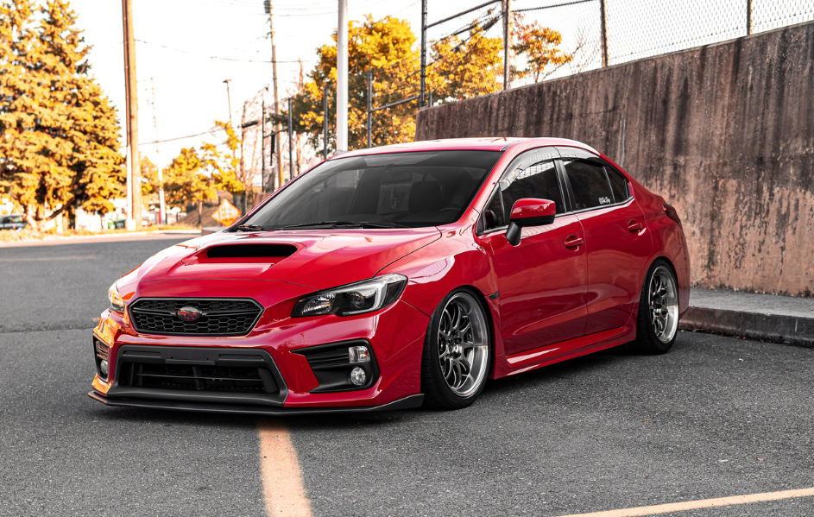
(This car weighs around 1 tonne):

- On a scale from 1 (not concerned at all) to 10 (extremely concerned), how worried are you about the amount of waste the world produces and how it is managed? _________
- What is ONE thing you have heard about global waste that has shocked you?
________________________________________________________________

- What is ONE positive change you can make in your life around waste? _________________________________________________________________ What is ONE major global policy change you would like to see happen in the next two years? _________________________________________________________________

- Find someone in the class you haven’t spoken to in a week. Choose four of the questions above you are most interested in. Interview your partner and get ready to share their answers with the class. See if you can find answers to questions (iii) and (iv) on the internet and see how close you guesses were.

- Class discussion. The teacher will briefly choose a few pairs to share some of their answers and invite the class to discuss these further.

Viewing:

- Watch “Complete Rubbish” once right through.

- Find out when your partner’s birthday is. The person whose birthday is closest will now be the Schreiber*in and the other partner will be the Prüfer*in. See how many of the following questions you can answer from recall.

Quiz:

- What is the “terrible crime” that Duncan commits when he first moves into his new German WG? __________________________________________________________ (1 Punkt)

- What does “Mülltrennung” mean? __________________________________________________________ (1 Punkt)

- “A whole new world opened up for me under that bench Jörg”. See how many of the different types of rubbish you can remember by labelling the 8 bins below:

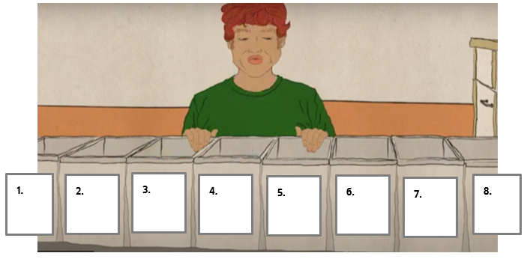
(4 Punkte)

- What is “Pfand”? (And can you say it?!) __________________________________________________________ (1 Punkt)

- Where is Jörg off to for the evening? __________________________________________________________ (1 Punkt) How many events like this have you both been to and what were the themes?
_______________________________________________________________________________________________________________________________________________________________________________________________________________

- Swap papers with the pair next to you. Watch “Complete Rubbish” a second time and mark each other’s answers. Fill in the details they missed. Be generous rather than picky with your marking!

After viewing:

- Demonstrationsplakate!

Germany is country of frequent and passionate demonstrations and protests. As part of the global climate demonstrations, our class is preparing to hit the streets to raise the public’s awareness of the need to recycle, reduce our waste and change the habits of our plastic overusing, throwaway society.

Task:

- As a pair, your job is to design four pithy slogans auf Deutsch to be printed onto banners and signs for the demonstration march. Your mission is to:

- Use at least 2 different modal verbs to create strong statements that will rouse the onlookers to action (e.g. Wir dürfen nicht mehr…!!)
- Use at least 2 different forms of the verbs, i.e. for “ich”, “du”, “man”, “wir” etc.
- Use at least 1 “Befehl” or imperative verb. (Kauft weniger Plastik!)

Make it personal – look at your answers to v, vi and vii above to give you some inspiration! Your teacher might brainstorm some useful language for making strong statements on placards e.g. “Schluss mit…!” (down with…!)

- When you are happy with your slogans and the teacher has checked them, paint the pithiest onto pieces of board or card and attach a stick. Use colours, borders and imagery to make the sign stand out. The most striking will be collected to decorate the wall of the classroom, or even the window or corridor as a bold public statement against “Umweltverschmutzung”!

- Donaudampfschifffahrtsgesellschaftskapitän!

In your adventures through the German language, you might have noticed some frighteningly long words. These are compound nouns and can be a lot of fun. “Mülltrennung” is an example – it is made up of two shorter words “der Müll” (rubbish) and “die Trennung” (separation), but compound nouns can theoretically contain any number of words. The example above in bold literally means: the captain of the Danube steamship company! (The Danube is a famous river that flows through southern Germany). Other wonderful compound words include the word for sloth: “das Faultier” (literally, “lazy animal”) and vacuum cleaner: “der Staubsauger” (literally, “dust sucker”)!

Another great thing about compound nouns is that anyone can invent new ones, which you’re about to do!

Task:

There are thousands of objects, feelings or phenomena in life that have no words yet to describe them. You and your partner are going to discover some of these words now! To help find one, consider what smaller common words it might be made up of and look these up in German. Then put them together. Make a list of 3 or 4 new words. Check these with your teacher and write your favourite in large colourful font on card. Put each part of the compound word on a separate piece of card.

Tips:

- Placing an “s” between smaller words can help the compound word to flow.
- The new word will take the gender of the last word in the “compound”. For example, “Mülltrennung” is die because “Trennung” is feminine.

Here are some newly invented words to inspire you. See if you can work out what they mean:

“die Sonntagstraurigkeit”

“die Fahrradfahrensfreude”

“der Geschwisterstreit”

“die Umweltverschmutzungspanik”

…Now, your turn. Viel Spaß!

Extra exercise:

- Each pair introduces their favourite invented compound word/s to the class by sticking or writing the word up on the board.
- The other pairs try to guess what the word means.
- When all the pairs have presented their words, all the students return to the board and have 1 minute to mix and match the compound words there to create yet more new words. The more creative and crazier the better! For example, the above examples could become: “Sonntagsgeschwisterstreit” (Sunday sibling fight) or “Fahrradfahrenspanik” (bicycling panik). After a minute, the teacher will give a signal and the students return to their seats. The teacher will then pick out a few entertaining examples and go through them with the class.

