Learning Outcomes:

In this lesson, you will:

- Compare and contrast practices and rituals characteristic of a German and a Kiwi Christmas.
- Reflect on and discuss their opinions regarding attitudes towards health and the body in Germany and New Zealand.
- Research, present and compare taboos from other world cultures.

Before viewing:

- How do you celebrate a Kiwi Christmas? Fill in the first column of the “Christmas table of sensory delights” below to record your typical experiences on December 24, 25 and 26. In a multi-cultural country like New Zealand, there is no right way of celebrating Christmas, and many families don’t celebrate at all, but might spend their days off in a different way. This is all useful information.
- Find two classmates who you haven’t talked to yet this week and briefly interview them on their sensory experiences of Christmas. If there is a match with yours, place a tick in the column, otherwise record the new information and get ready to share.
- Do you know how Germans celebrate “Weihnachten”? Jot down any ideas you may have in the last column. If you don’t know, have a guess. You can always cross things out later on.

The Christmas Table of Sensory Delights!

An Weihnachten… | Ich: | Name: | Name: | “Typisch Deutsch”:
schmecke ich:

rieche ich:

sehe ich:

höre ich:

erlebe /mache ich:

After viewing:

- What did Duncan and Jörg teach you about a “deutsche Weihnachten”? Add any new information to the last column of the table above.

- Join up with your second interviewee from the table exercise above. Choose 4 of the following stills from episode 5 and come up with a caption to explain the image. (Extension for senior students: do this in German).

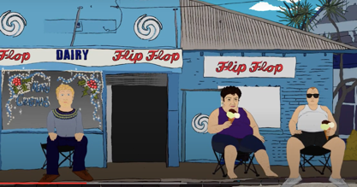
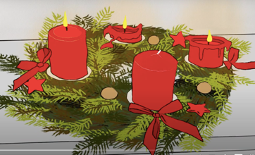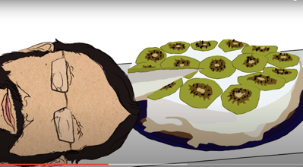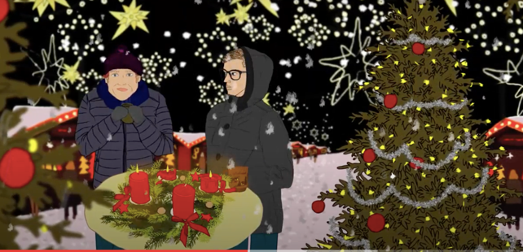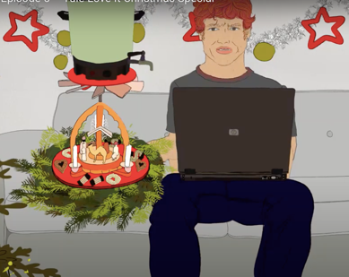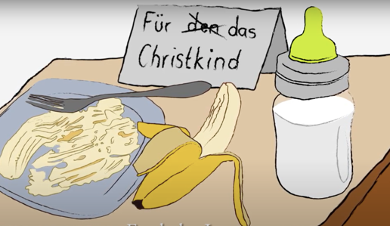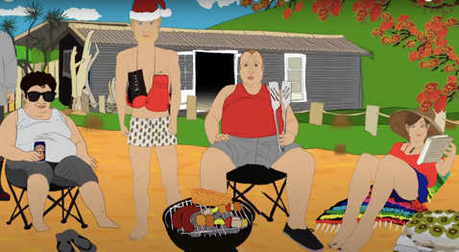

In 2022, the government of Aotearoa / New Zealand is introducing the very first Matariki public holiday. Until now, there has been no official national celebration to acknowledge te ao Māori and no rituals to help brighten the long Southern Hemisphere winter. It is time to put both these things right…
Task: This class has been employed as “Holiday Designers” to help get Matariki celebrations off the ground. In groups of three you will design and present to the class your best ideas for the nation’s midwinter holiday. The class will then vote on the very best ideas, which will be presented to the Minister of Internal Affairs.

- How much do you know about Matariki? The person in the group with the next birthday will look up information about the origin and meaning of Matariki and read it out. The other two will share the task of notetaking.

- Using what you have found out, brainstorm ideas as a group. The person with the furthest-off birthday will complete the table below. Remember, your holiday celebrations should raise respect and awareness for the Māori origins and traditions of Matariki and also include activities that bring light, warmth and good cheer into our long, dark winter.
The Matariki Table of Sensory Delights!

An Matariki…
schmecken wir:

riechen wir:

sehen wir:

hören wir:

erleben /machen wir:

- The teacher will ask groups to share their best ideas and record these on the board.

Achtung Künstler*innen, Musiker*innen, Dichter*innen, Wissenschaftler*innen!

What are your talents and interests? Choose one of the following tasks to work on for homework or in the next German class. You can work on your own or pairs or in small groups. You will hand your task into your teacher and present your grand works to the class!
