Learning Outcomes:

In this lesson, you will:

- Learn about, discuss, and compare etiquette and practices around a German Sunday.
- Write and speak using a range of grammar and sentence structures including modal verbs and time, manner, place to communicate details about German Sundays and an invented 8th day of the week.

Before viewing:

Task 1: Human Energy Output Levels

In episode 8, we are introduced to a system that Jörg has devised to measure people’s energy output during the week. We are going to test his theory.

- Using the starters below, write 7 sentences listing the main activities you take part in each day, including school, extra-curricular activities etc. For example: “Am Mittwoch gehe ich zur Schule. Ich spiele nachmittags Rugby und übe abends Klavier.”

Am Montag…

Am Dienstag…

Am Mittwoch…

Am Donnerstag….

Am Freitag…

Am Samstag…

Am Sonntag…

- Which days are your most active? Plot your “energy output” for each day of the week on Jörg’s graph below, drawing seven crosses. Then join the crosses to create a line graph of peaks and troughs. What are the busiest and most chilled points in your week?

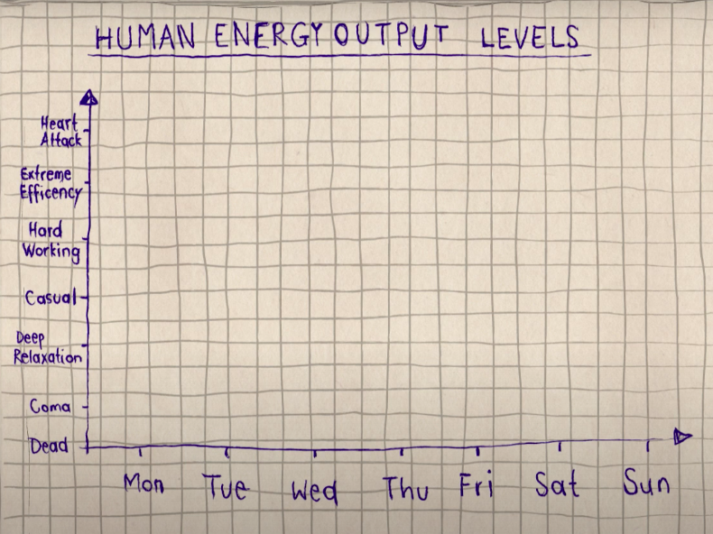

After viewing:

Task 1: Was ist deine Meinung?

- Add to your graph above Jörg’s two lines describing Germans’ and New Zealanders’ weeks. Do you come out you more German or more Kiwi? Compare with the people around you. Who is the most German? Who is the most Kiwi?

- In your opinion, what are the advantages and disadvantages of a German Sonntag compared to a Kiwi Sunday? Fill out the table below to find out:

 | Deutscher Sonntag: | Kiwi Sunday:
2 Vorteile:


2 Nachteile:

- What is something you found particularly strange or funny in the video? What is a question you have for the class or the teacher?

- When it comes to Sundays, would you prefer to live in Germany or New Zealand? Why or why not? Share your opinion with your partner and get ready to discuss with the class.

Task 2: Was hast du gelernt?

You have been asked to prepare an “instruction manual” for Kiwis going to live in Europe to help them avoid stepping into “Fettnäpfchen”. The 6 pictures below are part of a chapter on German Sunday etiquette.

For each image, write a sentence in German, using EITHER:

- A MODAL VERB

OR

- A VERB with GERN, NICHT GERN, or GAR NICHT GERN to show likes or dislikes.

Tip: Use the starters and words in the bubble below to help you.

Challenge: In one sentence, practice using the TIME, MANNER, PLACE structure.

E.g. “Am Sonntag in Deutschland mag man morgens lange im Bett bleiben.”

Bilder: | Am Sonntag in Deutschland…
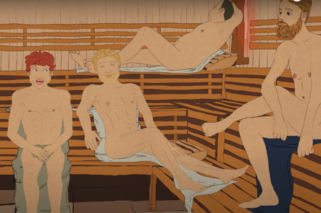 | darf man (nicht)…. will man…  kann man (nicht)…. muss man…  soll man (nicht)…. mag man…  geht / isst / spielt man gern / nicht gern… / gar nicht gern…
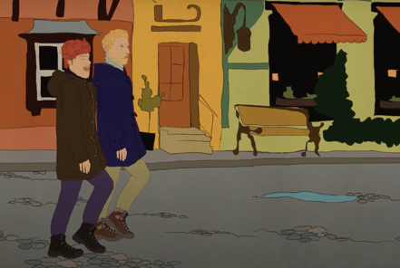

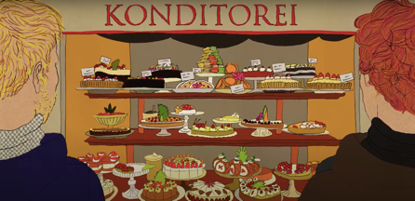

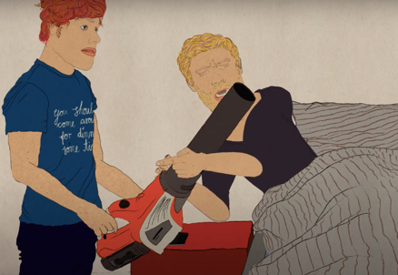

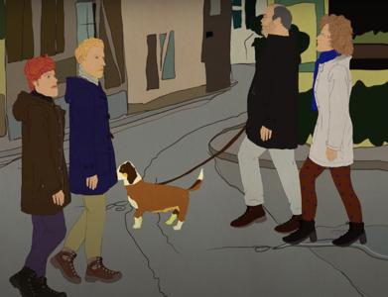

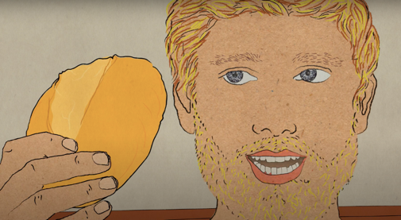

spazieren gehen

die Sauna
abends
morgens

sich entspannen
das Brötchen

nachmittags
Kaffee und Kuchen

der Lärm

Task 3: Stell dir vor!

You’ve been headhunted by the New Zealand government to head a thinktank to design an 8th day of the week. What would include in this day as options, traditions, non-negotiables to make life in New Zealand as we know it WAY BETTER!

- Give your day a name and, in the left column of the table below, write at least 4 sentences explaining what you want us to do and not do on this day. Include juicy detail, including times, manners and places. Use the coloured options below to inspire you. Then let your imagination run wild!

- In the right column, draw some thumbnails or symbols or find some images on the internet or in magazines to visually represent your ideas.

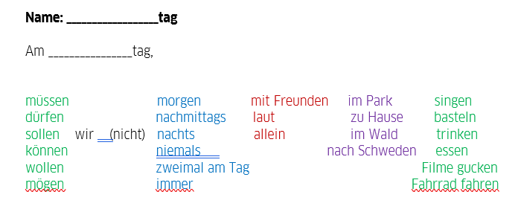

Am __________________tag… | Mein Bild / Symbol

- Get ready to present your day to the class or hand in to the teacher for feedback.

