Learning Outcomes:

In this lesson, you will:

- Compare and contrast the New Zealand and Australian cultures.
- Discuss your experience and knowledge of the New Zealand and Australian mentality of “She’ll be Right”.
- Discuss and research different national stereotypes from around the world.
- Differentiate between harmless and harmful stereotyping.
- Devise a series of positive solutions to the issue of racism/ negative stereotyping in a community within a hypothetical scenario as a person in a position of influence.

Before viewing:

Task 1: Prior knowledge:

- Many people around the world believe that Kiwis and Aussies are basically the same. Das stimmt doch, oder? Use the venn diagram below to work out what qualities and tendencies they share (in the overlapping section) and which qualities and tendencies you believe are specific to each country.





- In episode 9 of Lifeswap, Duncan introduces Jörg to a phrase and life philosophy used often by Kiwis and Aussies: “She’ll be right”. Have you ever heard this phrase? Check in with the people around you. Imagine a German exchange student had just arrived in the class. In pairs, write them a definition using 10 words or fewer.

- Do you know a “she’ll be right” New Zealander or Australian, who fits the descriptions on the board. Share a story with the people around you and be prepared to share any good ones with the class.

After viewing:

Task 2: Stimmst du zu?

A class discussion is always better when you’ve had an opportunity to reflect on the topic yourself and when not everyone has the same opinion! Spend 5 minutes writing a review or personal response based on 2 or more of the following questions and get ready to share any insights with a partner and the class.

- What did you agree with or enjoy the most?
- Did you disagree with anything?
- What was the funniest moment for you and why?
- Did you think the makers of the animation navigated the sometimes fine line between funny and true, on the one hand, and cliché or stereotyping on the other?

Task 3: “Stereotypen um die Welt” – A fun group research task

Have you ever considered the hundreds of national stereotypes that exist around the world? What do the Taiwanese think of the Chinese, what do Iranians think of Scots, what do Polish people think about French people, what are the French stereotypes about Iranians etc., etc.? Are you ready to be a traveling spy in this strange and fascinating world…?
- Find a person in the class to work with who has a birthday near yours.
- The teacher will hand your card with the names of two countries, one underlined, one not. The underlined one is your “home country”, the other is the “focus country” that you will research “through the eyes” of your home country. Using one device between you, spend 8 minutes gathering as much information you can about how your “home country” commonly views the other country. Write notes in the box provided below. This part might take some time and patience. Ask the teacher if you need help.

Tip: if you’re a visual learner, it might help to do an image search of the stereotype you are researching.

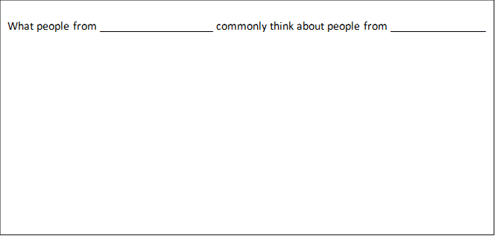

- Write 2 or 3 sentences in German to sum up what you have found. Imagine you are form the “home country”. Use the words “dass”, “weil”, and “aber” to express “your” country’s opinions about the focus country. Remember to send the verb to the end you are using “dass” or “weil”. Use the text in bold below to help you:

E.g. “Wir kommen aus Amerika. Wir finden / glauben / denken, dass Neuseeländer*innen lieb und friedlich sind, weil sie in einem schönen Land mit viel Natur wohnen.

- Was hast du gelernt?

Which stereotypes were new and interesting to you? Write down in the bubble below three you remember from your classmates’ research. Try adding another “dass clause” and use the following model sentences to help:

Ich fand es interessant, dass viele Schott*innen denken, dass Kanadier*innen höflich aber zurückgehalten sind.

Am Interessantesten fand ich aber, dass Engländer*innen der Meinung sind, dass Amerikaner*innen laut sind.



Task 4: Lass uns schreiben, lass uns diskutieren!

As wars continue to trigger waves of migration across large parts of the world, the topic of racial and national stereotyping has huge and ongoing relevance and importance for a peaceful future on Earth. Choose one of the following options to write about for homework. Write 1 page in English or German. Be ready to share your ideas with the class and teacher.

- Consider all the stereotypes you heard today and the hundreds you didn’t hear. Are these opinions racism or something else? Are only negative opinions about another country or culture racist or can positive stereotypes also be harmful? Do you think stereotypes about a country arise from actual relationships with people from that culture or some other way? Address any or all of these questions.
- Imagine you are EITHER:

- a principle in a school where there are lots of children from migrant families OR
- a mayor in a town where lots of immigrants from war-torn countries are arriving OR
- the Prime Minister of New Zealand.

Money is not an issue. What are 3 specific policies or initiatives you would introduce to help turn national and cultural differences among the populations you are responsible for into an enriching rather than a dividing force.

