Learning Outcomes:

In this lesson, you will:

- Write about, discuss, and compare habits and attitudes around talking about your own achievements.
- Analyse and discuss the reasons for and your experience of New Zealand’s “tall poppy syndrome”.
- Use German to explain Māori attitudes towards talking about your achievements and qualities.
- Write and speak German phrases showing off your talents and achievements, including the past tense, the conjunction “weil”, first and third person verbs, and exclamations of affirmation!

Before viewing:

Task 1:

A: Personal reflection

Consider the following situation: You have just received a major award or achievement in your sport / cultural area / science fair etc. When you arrive at school, you see a group of classmates, some of them friends, waiting for German class. Take 5 minutes to think carefully and write honestly in English or German from your own perspectives on the following questions. Be ready to share.

- Do you mention your achievement or not?
- If so, how would you bring it up? If not, why not?
- Imagine you have chosen not to mention it, but a friend brings it up in front of the others. How would you feel? What would you say or do? What’s important for you here?

B: Pair share

Now take a few minutes to interview one of your classmates on the 3 questions above. Be a shrewd cultural investigator – use question words (When, Who, Why, How, Where, etc.) to elicit more information about the reasons behind their answers. For example: When does acceptable pride cross over unacceptable boasting? Ask your partner where exactly the line is for them…

C: Class discussion

Be ready to share some of your answers and possible reasons behind the answers with the teacher and the class.

After viewing:

Task 1: Was hast du gesehen?

- In pairs, see how many of Duncan’s 5 rules for talking about your achievements in New Zealand you can remember. Is there anything he’s missed? Maybe you can add one of your own.

1.

2.

3.

4.

5.

6. Bonus:

B: As a class, see if you can complete the list.

Task 2: Was hast du verstanden?

The idea that you should be humble about your qualities and achievements is deeply rooted in the psyche of the New Zealander. In the scene where Duncan is demonstrating his modesty about writing a great essay in the wharenui, we can see a glimpse of a Māori proverb (saying) on the blackboard:



- In pairs, using the visible fragment above, search the Internet to complete the proverb. Write it out in te reo below along with an English translation:

Te reo:

English:

- Imagine you are preparing a friend from Germany for their school exchange in New Zealand. You don’t want them to be social outcasts! In your pair, write a sentence in German to explain the proverb. Note: this is not a translation (Germans might not know what a kumara is and usually appreciate simple, direct instructions!).

Deutsch:

Task 3: Was hast du erlebt? Und was denkst du?

Choose 1 of the following 2 sets of questions. Spend 5 minutes thinking and writing down your thoughts in German or English and get ready to pair share and then take part in a class discussion. Remember, the more detailed and honest you can be, the more heated and interesting this class will be…

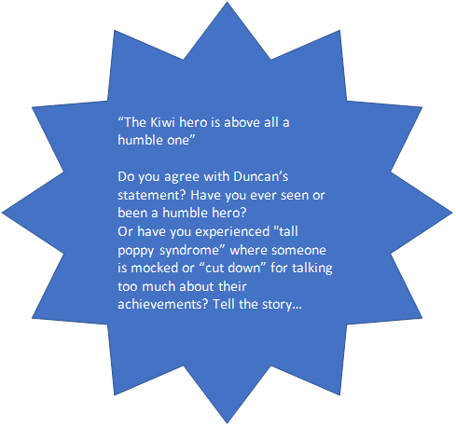
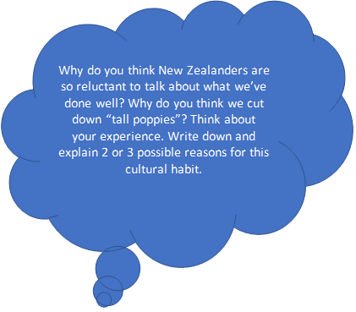

Task 3: Meine Erfolge!

As Jörg demonstrates, Germans are often happy to publicly celebrate theirs and others’ successes. “I’m also super talented at volleyball!” It’s now time for us to be a bit German and celebrate ourselves!

- Think about a talent you have or a success you’ve had in your life that most of the people in this class don’t know about. Use the following starters to help you write 4 or 5 sentences about yourself and 1 or 2 sentences about someone else in the class whose achievements and talents you know about (challenge: choose someone who might be surprised to hear from you). Note: absolutely no humility allowed!

- Ich habe einmal…
- Dieses Jahr / Letztes Jahr habe ich…
- Ich bin eine sehr begabte / ein sehr begabter….
- Ich bin stolz auf mich, weil…
- Ich bin super talentiert im…
- Ich kann unglaublich gut…
- Ich bin super, weil ich…
- Meine Freunde finden mich….., weil ich….
- Meine Familie findet mich …, weil ich…

- Practice 2 or 3 sentences with a partner. Get ready to stand up and proudly present some of your great traits and achievements to the class. Note: you have to learn the phrases off by heart – no shy reading!

- Our tall poppy Kiwi culture won’t change itself. We need you! When you hear someone else present a sentence about themselves, choose one of the following encouraging exclamations. See if you can drown out the people around you!

- Stimmt das? Das ist einfach fantastisch!
- Gut gemacht! Wunderbar!
- Ich bin wirklich stolz auf dich!
- Echt jetzt? Das finde ich toll.
- Warum hast du das noch nie erwähnt?

