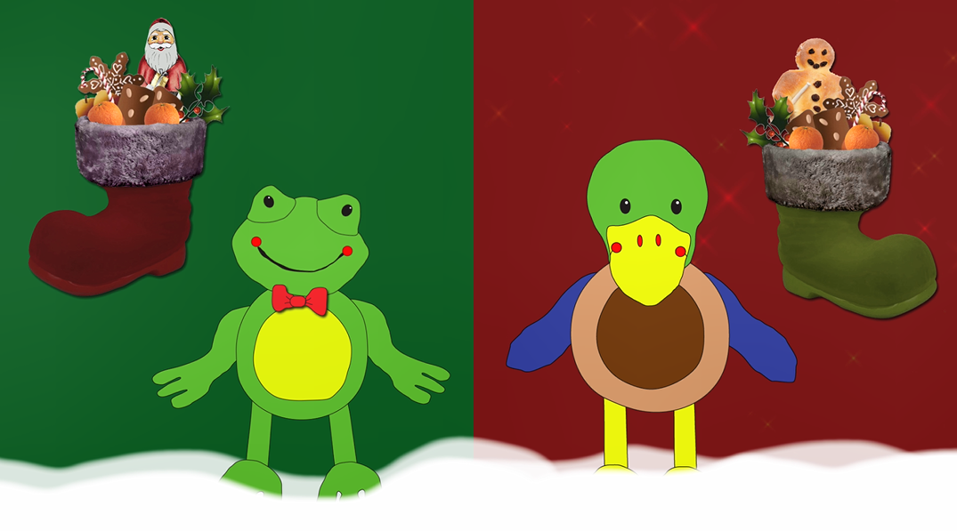  Weihnachtszeit in Deutschland mit Felix & Franzi  (Christmas time in Germany with Felix & Franzi) | Send the entry to:  Goethe-Institut London  BKD: Felix & Franzi Xmas  50 Princes Gate  Exhibition Road  London SW7 2PH  UK
Dear Learners of German,

Felix and Franzi are in the UK now but they remember what Christmas time was like in Germany. In the film, they show what usually happens in Germany in December. Watch the film and circle the right answers in the questionnaire below. Add a greeting for the festive season for Felix and Franzi and send us your entries. As a thank you, we will send you a small gift via your school.

Which colour is Felix’ school bag? Look at the picture in the living room. grün / blau / gelb
What does Felix wish for? ein Fußball / ein Lebkuchenhaus / ein Fahrrad
What do German children do on 5 December? Kuchen backen / Schuhe putzen / Geschenke einpacken
What can you find in the calendar under number 12?
ein Schneemann / ein Nikolausstiefel / ein Stern
When does Father Christmas visit the children in Germany? am Morgen / am Abend / in der Nacht
What is the magic word? Felix sings it at the end._____________________

Your name and your grade: _________________________________________

Your school with address: __________________________________________

Your teacher: ____________________________________________________

Can you add a greeting for Felix and Franzi in German?

________________________________________________________________


