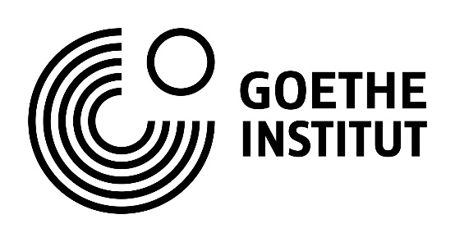

Application form
DocTrain
Documentary Film Training

by Goethe-Institut and Moscow School of New Cinema

May 12th – 19th, 2019
Moscow school of new cinema, Leningradsky Pr. 17

Please fill in this application form in English and the application form in Russian in a separate file and submit both applications to doctrain-moskau@goethe.de
until April 15, 2019 with all the mentioned attachments and material.
Applications in only one language unfortunately cannot be accepted.

- Applicant registration data
1.1 Name
1.2 Mobile phone
1.3 E-mail
1.4 Residence address
1.5 Registration address
1.6 Place of study
1.7 Place of work
1.8 Do you have the possibility to pay for lodging in Moscow on your own?
- Project description
2.1 Project logline (short film summary stating the main dramaturgic conflict in 2-3 sentences)
2.2 Project synopsis (short linear summary of the plot on one page)
2.3 Project treatment (more detailed story narrative on 5-10 pages). Please attach the treatment to the application form as a separate Word or PDF-file.
2.4 Project videos
If you have any completed project video material: a teaser (up to 60 sec.), a trailer (up to 5 min.), footage examples (up to 5 min.), please provide below the links to your videos on Youtube, Vimeo, Google Drive etc. as well as the login data, if the access to your material is restricted.
Applications with no available video material will still be considered by the jury.
2.5 Description of the current project situation in terms of content, finances and production.

2.6 Financing and evaluation strategy: How are you going to finance and evaluate your project? Do you have any potential co-producers, broadcasters and other partners in mind?
- Motivation letter
Please state in free form why it is important to you to participate in DocTrain
- Applicant CV
- Applicant filmography
- Applicant photo
Please attach your photo with a resolution of no less than 300 dpi.

