Enter Africa
Accra

Open Call for Application

N.B. We are looking forward to compose a diverse team from diverse backgrounds, social skills, and creative roles to come together as one. Therefore, being who you really are while entertaining the questions will make you a contender.

Deadline: May 25th, 2018

Dear applicant, please e-mail this document to: info-enterafrica@goethe.de

- Please introduce yourself. (Approx. 300 words). Include (Full Name, Gender, Birth date, profession and interests and phone number)

- Why would you like to take part in this programme? What is your motivation? (Approx. 300 words)

- My three ideas for the future of Accra are… or - My three concerns about Africa’ s future are… (Approx. 300 words)

- Do enjoy your time filling in the questions below. (Approx 100 words for each question)

- If someone wrote a paper article about you, what would the headline (title) be?

- What is your favorite game (digital or analog) and why?

- How would you sell a used plastic bottle?

- If you were a superhero, what would you want your super powers to be?

- We've been asking all the questions until now. For a change, what would you like to ask?

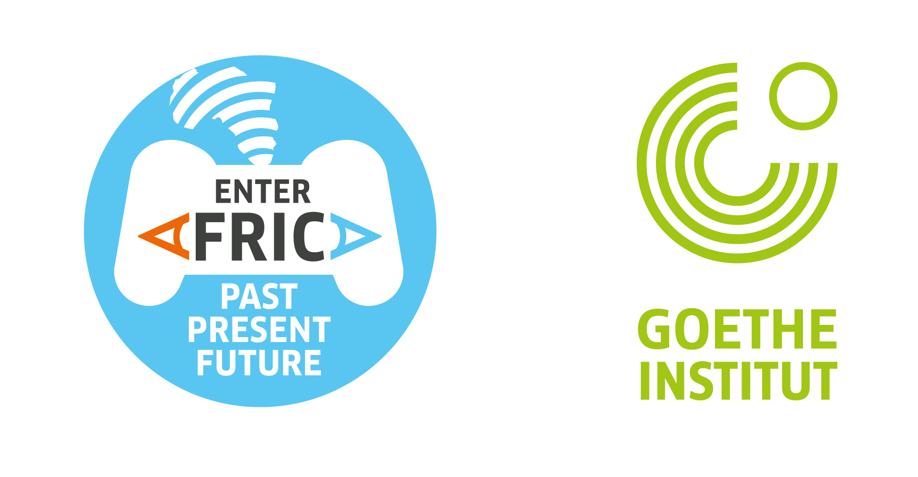

Thank you for your interest in Enter Africa.

