**Key Note: Joe Dale**

**Remote language learning reconfigured: A pedagogical paradigm shift?**

***Ideas and tools for supporting remote MFL teaching***

In this practical session, Joe Dale, independent languages consultant from the U.K. will explore how the global language teaching community has risen to the challenge of moving their teaching wholly online and how attitudes to educational technology may have changed as a result. Joe will provide some timely advice on ways in which language teachers can enhance their remote teaching repertoire further with many practical examples. He will also share a comprehensive resource including advice and tutorials to support you during these unprecedented times.

Joe Dale is an independent languages consultant from the UK who works with a range of organisations such as Network for Languages, ALL, The British Council, the BBC, Skype, Microsoft and The Guardian. He was host of the TES MFL forum for six years, former SSAT Languages Lead Practitioner, a regular conference speaker and recognised expert on technology and language learning. He has spoken at conferences and run training courses in Europe, North America, South America, the Middle East, the Far East and Australasia. He was a member of the Ministerial Steering Group on languages for the UK coalition government and advised on the Linguanet Worldwide project for The Language Company. He created ICT activities for the new Institut Français, ALL and Network for Languages Primary French Project Niveau Bleu, Blanc and Rouge courses and was short-listed for a NAACE Impact Award in 2013 too. Joe supported the Erasmus Plus project Conflict to Cooperation with 5 European countries and is currently involved in the Supporting Schools Reform in Algeria project through the British Council. He was recently described in a Guardian article as an 'MFL guru' and 'the man behind the #mfltwitterati.'

**Webinar 1: Dr Judith Rifeser**

**Using film as a vehicle for teaching German**

In this session, Judith will share lots of practical examples for the use of German films in the KS3-KS5 classroom, using film not as an add-on but as a central element in a Scheme of Learning. Film cannot only provide an engaging, authentic and purposeful context for learning but it can also be used as a vehicle to improve pupils' listening, reading, writing and speaking skills. In addition, film lends itself to nurture what the Council of Europe (2001) suggests could be seen as the "fifth skills". That is, a key skill for living in our diverse, world, showing its potential for supporting intercultural understanding and cross-curricular learning and teaching.

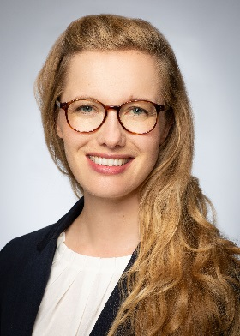Judith is a MFL teacher, researcher, ALL London Committee member and filmmaker. A German specialist, she has been teaching modern foreign languages and EAL in the UK, Spain, Italy and the US in the primary and secondary school sector, as well as in higher education. She is a lecturer on the PGCE Secondary Languages Programme at Goldsmiths and a Teaching Fellow for German at the IoE. Previously, she was Head of KS5 German and schoolwide Teaching and Learning Facilitator in a London secondary school. She has worked with Into Film, the BFI, Linguascope and ALL to develop engaging authentic film resources for the languages classroom.

**Webinar 2: Wanda Marshall**

**Inspiring confident A Level language learners**

This session aims to provide teachers with ideas and plans to motivate and inspire their A Level students. We will have a particular focus on the Speaking exam, and the cultural and societal elements of the course, along with effective preparation for the IRP, with special consideration of what makes a good IRP topic. In addition, we will look at ideas for teaching the book and film at A Level, with methods for character and thematic analysis, along with essay writing techniques and strategies for students to self-monitor their work, even under exam conditions.

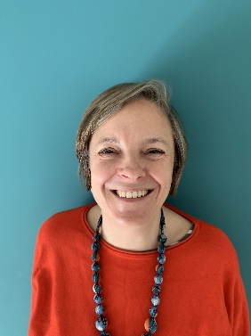

Wanda has been teaching German for twenty year and was formerly Head of German at a large north London comprehensive. More recently she has been an examiner for the AQA A Level speaking exam for the last six years and is currently working with Hodder, speaking at their film and literature student days and writing teacher and student materials for publication later this year. At the moment she is also teaching at a London sixth form college.

**Webinar 3 – Domini Stone & Lorna Price (Goethe-Institut London)**

***Introduction to The German Quiz Challenge: A free online assessment tool for Secondary Schools***

Are your pupils learning German? Are they aged between 13 and 16? Then check out the GERMAN QUIZ CHALLENGE! Come with us to Munich and meet five young skateboarders who will help test your students, whilst learning about a wide range of topics from the environment to the alternative music scene. This online application assesses your pupils’ abilities in reading, listening and writing and all without a minute’s marking.

Domini Stone, Manager for Educational Links at the Goethe-Institut London, will lead a session together with Lorna Price, Project Assistant in the Educational Links Department, and test your knowledge of German, whilst offering advice and ideas on how to integrate this application into the curriculum.