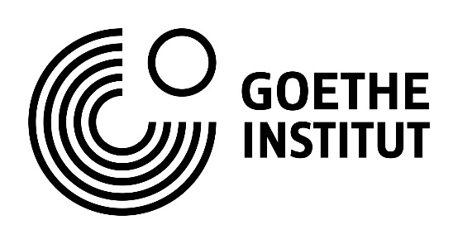
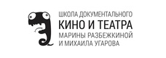

Application form
DocTrain 2021
Documentary Film Training

Organizers:
Goethe-Institut Moskau
State Museum Preserve "Rostov Kremlin"
School for Documentary Film and Theater by Marina Rasbezhkina and Mikhail Ugarov

Time: September 10 – 20, 2021
Place: State Museum Preserve "Rostov Kremlin"

Please fill in this application form in English and the application form in Russian in a separate file and submit both applications to doctrain-moskau@goethe.de
up to and including May 15, 2021 with all the mentioned attachments and materials.
Applications in only one language can’t unfortunately be accepted.

- Applicant registration data
1.1 Name
1.2 Date of birth
1.3 Mobile phone
1.4 E-mail
1.5 Residence address
1.6 Registration address
1.7 Place of study
1.8 Place of work
1.9 Do you have any other degree above your cinematographic education?

- Project videos and equipment
2.1 Film teaser (up to 60 sec.), or trailer (up to 5 min.), with English subtitles.
Please provide below the links to your videos as well as login data if the access to your materials is restricted.
The links and the login data should be valid until 20.09.2021.
Link:

Login:

Password:

2.2 Rough cut (up to 60 min. for a short documentary film, up to 90 min. for a feature-length documentary film), with English subtitles – a must for participation!
Please provide below the link to your rough cut that can be viewed online or downloaded as well as login data.
The link and the login data should be valid up to and including 20.09.2021.
Link:

Login:

Password:

2.3 Editing software and equipment
For participating in the project, you are supposed to bring your own laptop for editing your film with the help of your editing software.
Please confirm that you are ready to participate with your own laptop and please state the software you will be working with during the workshop.
I can bring my own laptop for editing: yes/no

Editing software:

- Project description
3.1 Project title
3.2 Project logline (short film annotation stating the main dramaturgic conflict in 2–3 sentences)
3.3 Project synopsis (short linear summary of the plot on one page)
3.4 Project treatment (more detailed story narrative on 5–10 pages). Please attach the treatment to the application form as a separate Word or PDF-file.
3.5 Description of the current project situation in terms of content, finances and production

3.6 Financing and evaluation strategy: how are you going to finance and evaluate your project? Do you have any potential co-producers, broadcasters and other partners in mind?
- Motivation letter
Please state in free form why it is important to you to participate in DocTrain Moscow
- Applicant CV
- Applicant filmography
- Applicant photo
Please attach you photo with a resolution not less than 300 dpi

