GET A CLUE: Reading Competition for young detectives
for all prospective detectives aged between 6 – 12 years

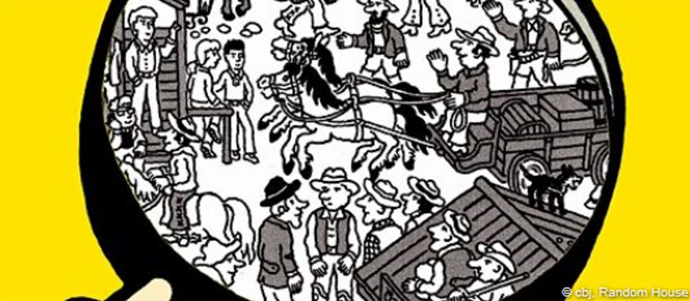

The Goethe-Institut Namibia and Julian Press (a German author for children’s mystery stories) is holding a detective reading competition. You are invited to help the “Liquorice Gang” solve a crime. All you must do is to read the short stories to find a clue in the picture linked to the riddle.

Grab this exciting opportunity and stand a chance to win a signed book from the author. Once you have solved the riddle, you may send the information (name, grade, address and solution to the mystery) below before or on the 30th November 2020 with “Get a clue” as the subject to library.windhoek@goethe.de

Your name: Grade: ______________________________

Home Address
____________________________________________________________________________________________________________________________________________________________________________________________________________________________________________________________________________________
Solution to the mystery:
__________________________________________________________________________________________________________________________________________
The chapters can be accessed via the following link:
https://drive.google.com/file/d/1b75OiIzdr31on3e4JHqo3IjkLpu2YekJ/view?usp=sharing

Yours

Goethe-Institut Namibia Library

