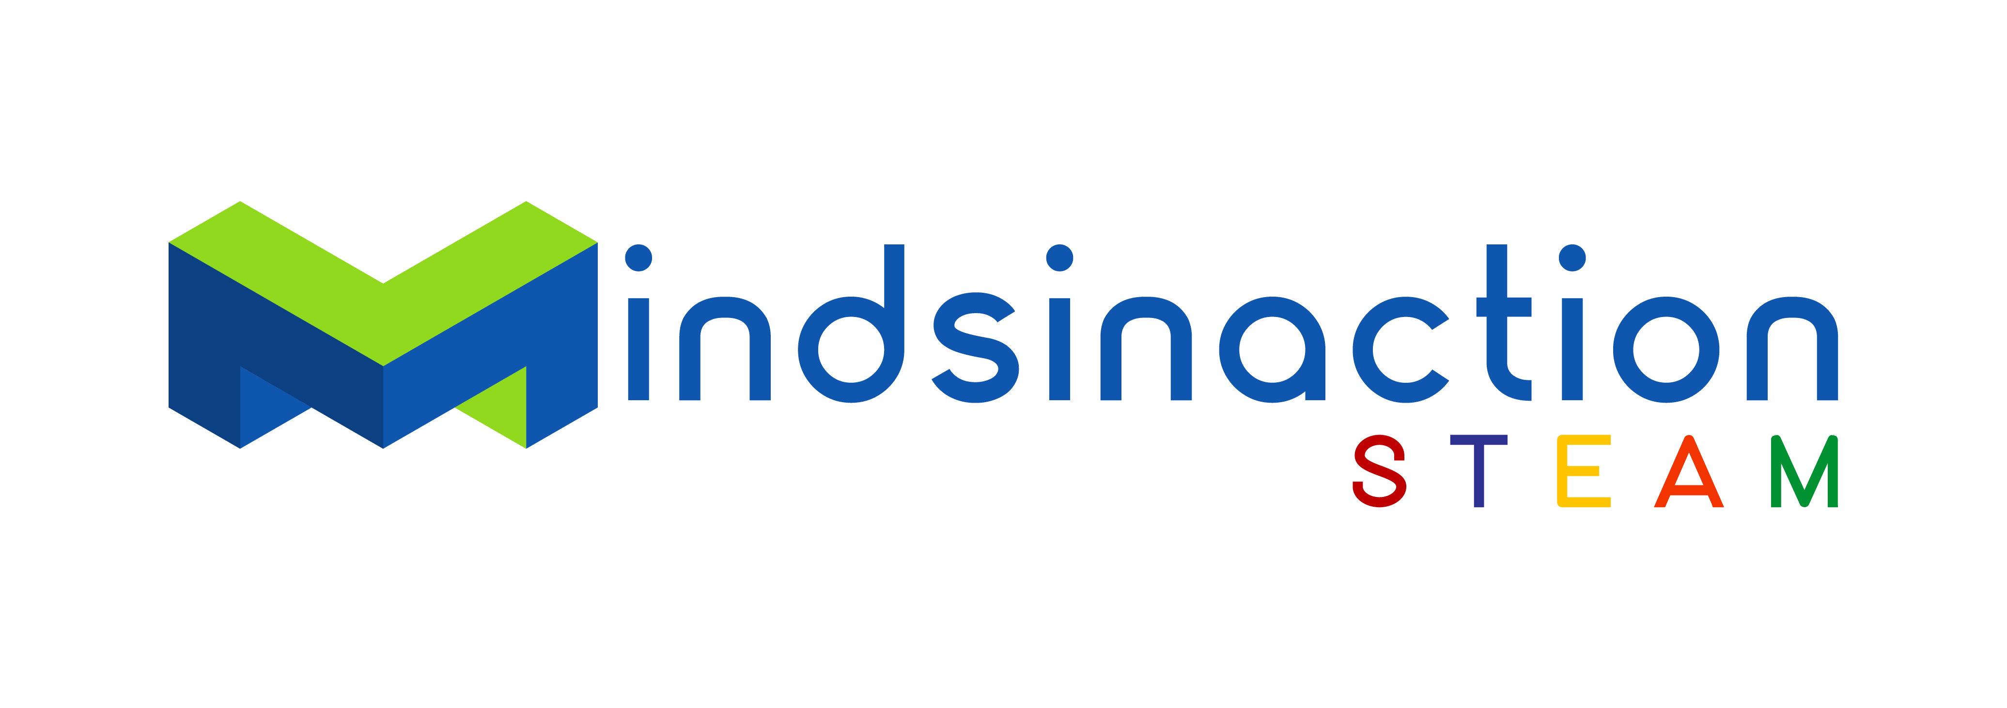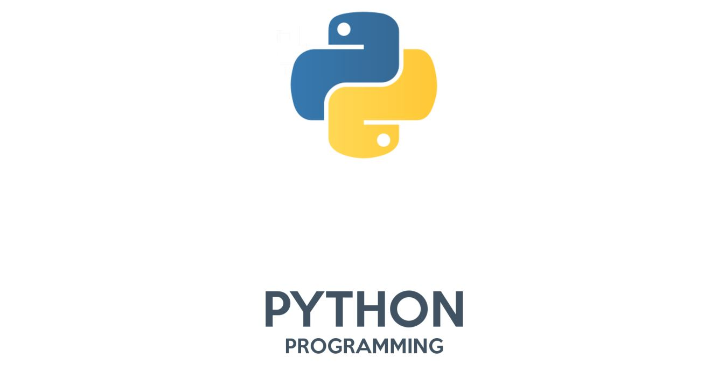
,

Registration Form
Data Science with Python

Hereby I register at the Python STEAM Program at the Goethe-Institut Namibia.

Details participant:

First Name:

Surname:

Cell Nr 1: Cell Nr 2:

E-Mail Address:

Prior knowledge to Programming:

What motivates you to take this course?

Windhoek, Date Signature:

Terms and conditions:
Course takes place from Monday, 14th November to Thursday, 17th November 2022 from 17h30 to 19h00.
(Dates and time are subject to change).
If enrolment in a particular group is insufficient on the starting date, we reserve the right to adjust the course format. Should we not have enough course participants, we reserve the right to cancel a course.

Full payment of 800 NAD per learner required prior to their participation.
Please attach proof of payment to library.windhoek@goethe.de .

No refunds will be paid once the course has started. A cancellation fee of 20% is payable before course commencement. Cancellations must be done in writing.
The Goethe-Institut cannot be held liable and accepts no responsibility for any injury, damage and/or loss to course participants and their belongings.
By signing above, you agree to have read and understood the terms and conditions.

