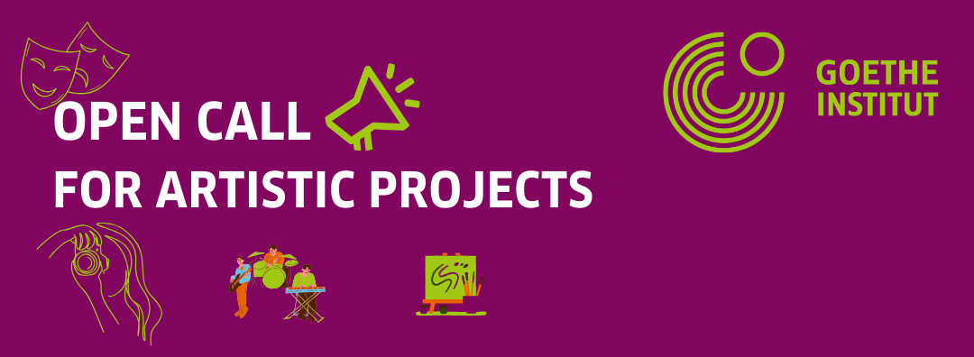

APPLICATION FORM FOR PROJECTS

All fields marked with an asterisk (*) need to be filled. Otherwise the application will be considered incomplete.
Names of the applicant/main curator (*): __________________________________________
Names of the initiative/organization/group (if applicable): _____________________________
Provisional title of the project (*): ________________________________________________
Which art forms does the project entail? (*)_______________________________________
___________________________________________________________________________
How many people will be involved? (*) ____________________________________________
Have you worked with the Goethe-Institut before? If so, when, where and for which project? (*) ______________________________________________________________________________________________________________________________________________________

Tell us about your project (*) – word limit of 300 words
Please type your answer here.

In what ways can we make this project a collaboration between you and the Goethe-Institut? We prefer supporting projects that do not simply consist of funding, but instead of a collaboration and working together on the process. (*) – word limit 150 words
Please type your answer here.

In your view, what distinguishes your project from existing ones and in what way is it unique? (*) – word limit 150 words
Please type your answer here.

Thank you for applying! Please send this document filled out and together with the budget proposal and the other required documents to assistant-kigali@goethe.de. You will hear back from us within the next 2 months.

