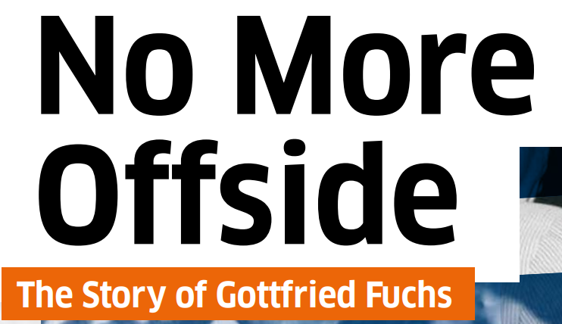
Feedback and Reflection
Choose one or two questions. Write your answers on a large sticky note and place it on the reflection wall (poster 13). There are no right or wrong answers.
Your Thoughts
- What do you take away from the story of Gottfried Fuchs?
- What is one thing you learned or didn’t know before?
- Did you identify with any part of the story? Why?
- Which word describes how the exhibition made you feel?
(for example: inspired, upset, thoughtful, confused, hopeful)
- If you could ask Gottfried Fuchs one question, what would it be?

Looking at today
- What can we learn from this story about choices and responsibility?
- Why do you think this story is still important today?
- What part of the story feels relevant to young people now?
- Finish the sentence: “This story shows that …”

Feedback for the exhibition
- What part of the exhibition did you like most / did you not like so much?

Thank you – Merci – Danke!

