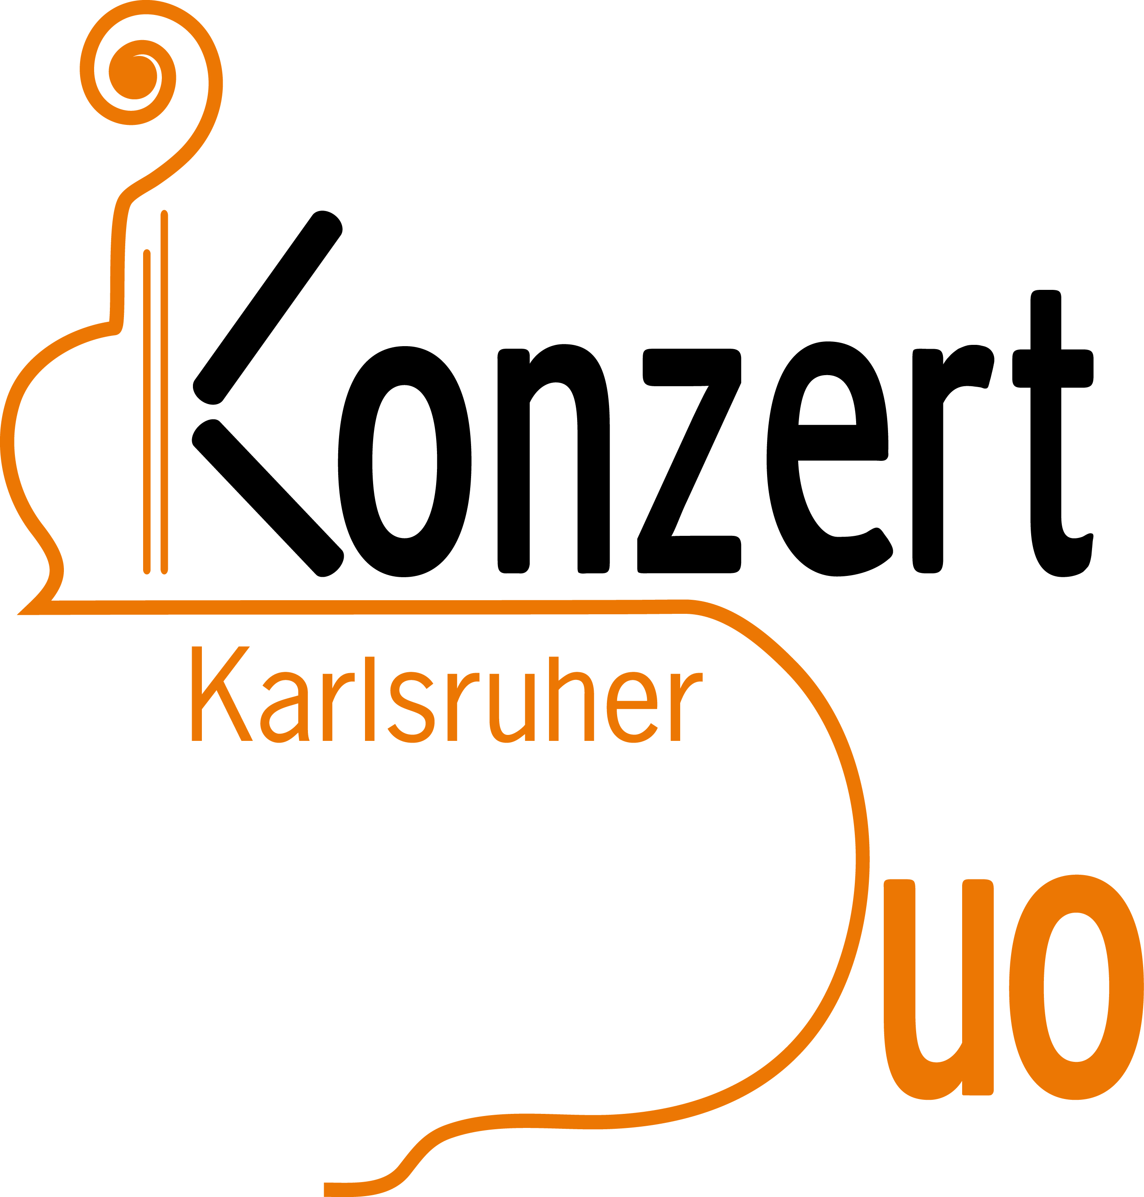

Karlsruher Konzert-Duo

Reinhard Armleder, cello
Dagmar Hartmann, piano

PROGRAM

Ludwig van Beethoven Sonata in A Major, Op. 69
(1770 – 1827) 1., 3. and 4. movement
Allegro, ma non tanto
Adagio cantabile - Allegro vivace

Felix Mendelssohn Bartholdy Song without words in D Major, Op. 109
(1809 – 1847) Andante

Robert Schumann Fantasy Pieces, Op. 73
(1810 – 1856) I. Zart und mit Ausdruck (Tender and with expression)
II. Lebhaft, leicht (Lively, light)
III. Rasch und mit Feuer (Quick and with fire)

César Franck 1st and 2nd movement from Sonata in A major (1886)
(1822-1890) / Allegretto ben moderato • Allegro - Quasi lento - Tempo I

Maurice Ravel Pièce en Forme de Habanera
(1875 – 1937) Presque lent et avec indolence

Enrique Granados Andaluza, Spanish Dance, Op. 37 No. 5
(1867 – 1916) Andantino, quasi Allegretto Andante – Tempo I

Orientale – Spanish Dance, Op 37 No. 2
Andante – Più mosso ed agitato – Tempo I

Manuel de Falla First Spanish Dance – “La Vida Breve”
(1876 – 1946) Allegramente e Vivo, ma non troppo

