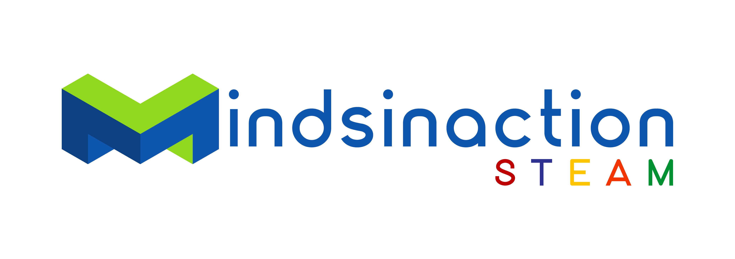

Registration Form
ROBOTIC COURSE Free Trails

Hereby I register my child for the Free Trials
Mindsinaction STEAM Programme at the Goethe-Institut Namibia.

Details parents:

Name of Parent

Cell Nr 1: Cell Nr 2:

E-Mail Address:

Details Child:

Name:

Surname:

Age: Cell Phone:

Windhoek, Date Signature:

Time Slot you with to reserves on the 14th January 2023:

Session 1 09h00 – 09h45 Session 4 12h00 – 12h45
Session 2 10h00 – 10h45 Session 5 13h00 – 13h45
Session 3 11h00 – 11h45 Session 6 14h00 – 14h45

Cancellation:
If you cannot attempt the free Trials please send us an SMS /WhatsApp to 081 807 6792 cancel in order to give your place to somebody on the waiting list.

